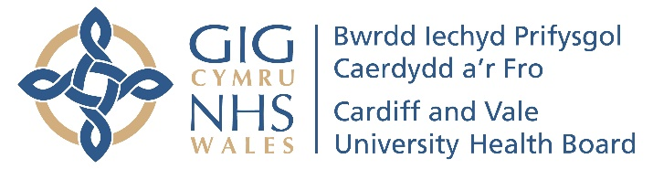

PATHWAY PROCEDURE

**[Title of Pathway/Procedure** (NB main keyword first)]

**Guidance for completion of pathways**

(Please delete this panel before sending to FST)

**Step 1. Draft your Treatment Pathway.** Please ensure:

**A. The title is clear** **– main subject /drug name first**

e.g. *Over-active Bladder – C&V Treatment Pathway version xx Draft for cMMG*

**B. The** [**formulary prescribing categories**](http://www.wmic.wales.nhs.uk/pdfs/DandTC_drug%20applications/Cardiff_Vale_Formulary_Prescribing_Categories.pdf) **are clearly stated** in the protocol. The choice is:

**G = General use including GPs,**

**R = Specialist recommended, S = Specialist initiated, SO=Specialist Only  
MC Path = Multiple Categories - See Treatment Pathway or other guidance,**

**H = Hospital only, NIP = Not In Pathway - Clinical Board Director Approval required, NF = Non-formulary**

**(Please indicate if a Shared care protocol exists or whether Homecare Service is applicable)**

**C. The pathway includes**: a clear layout, generic drug names, and abbreviations explained. ALWAYS INCLUDE “STOP CRITERIA”. Clear language - a non-specialist should be able to interpret it. Hyperlinks, references and a key to symbols may MAY be included if desired. The logo & footer as seen on this document, completed

**D. The pathway does not contain**: typos, unexplained abbreviations, or confidential data.

**Step 2. Submit your pathway to the Formulary Support team (FST) - who will check the above and liaise with your Lead CBP to finalise a draft for Lead Clinical Board approval.**

**The FST will convert to PDF format and undertake all requested minor changes from this point from a master version. Requests for future changes or for access to the editable document for major changes/updates should be emailed to the FST (**[**formulary.enquiries.cav@wales.nhs.uk**](mailto:formulary.enquiries.cav@wales.nhs.uk)**). Please ensure medical colleagues are aware of this.**

**Step 3. Lead CBP will obtain approval from their CBMMG then submit to other interested CBs to obtain their MMG approval. One received, and no further changes are required, the secondary CBP then emails the FST to notify approval and state “for Corporate Medicines Management Group” (or “cMMG”) in the email title.**

**Step 4. cMMG review and approves pathway, confirming prescribing categories**. Requests for change emailed to FST post meeting. Final version PDF circulated with cMMG minutes.

**Step 5. Posting on Clinical Portal, Inform and Good Prescribing Guide.** The Formulary Support Team (FST) will post on [**Pharmacy Clinical Portal**](http://nww.cardiffandvale.wales.nhs.uk/portal/page?_pageid=253,745936&_dad=portal&_schema=PORTAL)**>** **Medicine Treatment Pathways > A-Z**, add the link to the INFORM Formulary with appropriate keywords & arrange for the Good Prescribing Guide to be updated (as appropriate). FST will send an email out informing all staff of the changes. **Please do not** send pathways directly to anyone else for posting e.g. Pharmacy Office staff.

Thank you.

This procedure & possible template may be found on s/pharmacy/pathways.

Diana Fletcher 25.06.18

Updated categories 7/10/24

**BOX to be completed and added as footer to all pathways, please:**

|  |  |
| --- | --- |
| Author/contact person & email: | Date written: |
| Clinical Board: | Date of cMMG approval: |
| Version: | Review date: |
| CBP approval : (name and date) | Format/posting approval & date: |